

MACHAKOS UNIVERSITY

CENTER OF OPEN, DISTANCE AND e-LEARNING

IN COLLABORATION WITH

SCHOOL OF ENGINEERING AND TECHNOLOGY

DEPARTMENT OF COMPUTING AND INFORMATION TECHNOLOGY.

SCO 208 OBJECT ORIENTED ANALYSIS AND DESIGN/
SIT 264 UML

WRITTEN BY:

Mr. Martin Kimeu

Copyright © Machakos University, 2020
All Rights Reserved

SEP, 2021

CLASS DIAGRAMS

Unit Structure

- Introduction
- Class
- Attributes and operations/methods
- Responsibilities of Classes
- Abstract Class
- Standard Class Stereotypes
- Dependency

- INTRODUCTION

Class diagram is UML structure diagram which shows structure of the designed system at the level of classes and interfaces, shows their features, constraints and relationships - associations, generalizations, dependencies, etc.

- CLASS

A class is a classifier which describes a set of objects that share the same
o features
o constraints
o semantics (meaning).

Class Diagrams

UML class diagrams model static class relationships that represent the fundamental architecture of the system. Note that these diagrams describe the relationships between classes, not those between specific objects instantiated from those classes. Thus the diagram applies to all the objects in the system.

A class diagram consists of the following features:

Classes: These titled boxes represent the classes in the system and contain information about the name of the class, fields,

methods and access specifiers. Abstract roles of the class in the system can also be indicated.

Interfaces: These titled boxes represent interfaces in the system and contain information about the name of the interface and its methods.

A class is shown as a solid-outline rectangle containing the class name, and optionally with compartments separated by horizontal lines containing features or other members of the classifier.

As class is the most widely used classifier, there is no need to add the "class" keyword in guillemets above the class name. Class name should be centered and in bold face, with the first letter of class name capitalized (if the character set supports upper case).
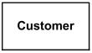

Class Customer - details suppressed

- ATTRIBUTES AND OPERATIONS/METHODS

Features of a class are attributes and operations. When class is shown with three compartments, the middle compartment holds a list of attributes and the bottom compartment holds a list of operations. Attributes and operations should be left justified in plain face, with the first letter of the names in lower case.
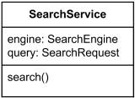

Class SearchService - analysis level details

Characteristics represented by feature may be of the classifier‘s instances considered individually (not static) or of the classifier itself (static). The same feature cannot be static in one context and non static in another.

With regard to static features, two alternative semantics are recognized. Static feature may have:

o different values for different featuring classifiers, or o the same value for all featuring classifiers.

Static features are underlined - but only the names. An ellipsis (...) as the final element of a list of features indicates that additional features exist but are not shown in that list.

Attributes of a class are represented by instances of Property that are owned by the class. Some of these attributes may represent the navigable ends of binary associations.

Objects of a class must contain values for each attribute that is a member of that class, in accordance with the characteristics of the attribute, for example its type and multiplicity.

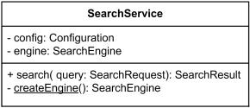

Class SearchService - implementation level details. The createEngine is static operation

Attributes or operations may be grouped by visibility. A visibility keyword or symbol in this case can be given once for multiple features with the same visibility.
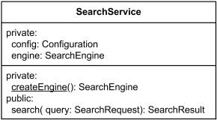

Class SearchService - attributes and operations grouped by visibility

Additional compartments may be provided to show other details, such as constraints, or just to divide features.

- RESPONSIBILITIES OF CLASSES

Knowing
- knowing about private encapsulated data
- knowing about related objects
- knowing about things it can derive or calculate

Doing
a. doing something itself, such as creating an object or doing

Calculation

- initiating action in other objects
- controlling and coordinating activities in other objects

Examples

a Sale is responsible for knowing its total (POS example) a Sale is responsible for creating SalesLineItems

- ABSTRACT CLASS

Abstract class was defined as class that can't be directly instantiated. Abstract class exists only for other classes to inherit from and to support reuse of the features declared by it. No object may be a direct instance of an abstract class, although an object may be an indirect instance of one through a subclass that is nonabstract.

We can probably relate definition of abstract classifier to abstract class. We may assume that in UML 2.x abstract class does not have complete declaration and "typically" can not be instantiated. An abstract

class is intended to be used by other classifiers (e.g., as the target of generalization generalization relationships).

Attempting to create an instance of an abstract class is undefined - some languages may make this action illegal, others may create a partial instance for testing purposes.

The name of an abstract class is shown in italics.
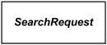

Class SearchRequest is abstract class

An abstract classifier can also be shown using the keyword {abstract} after or below the name.

- STANDARD CLASS STEREOTYPES

Standard class stereotypes include: «focus»

«auxiliary»
«type»
«utility»

«focus»

Focus is class that defines the core logic or control flow for one or more supporting classes. The supporting classes may be defined either explicitly using auxiliary classes or implicitly by dependency relationships.

Focus classes are typically used for specifying the core business logic or control flow of components during design phase.

«auxiliary»

Auxiliary is class that supports another more central or fundamental class, typically by implementing secondary logic or control flow. The class that the auxiliary supports may be defined either explicitly using a focus class or implicitly by a dependency relationship.

Auxiliary classes are typically used for specifying the secondary business logic or control flow of components during design phase.

«type»

Type is class that specifies a domain of objects together with the operations applicable to the objects, without defining the physical implementation of those objects.

Type may have attributes and associations. Behavioral specifications for type operations may be expressed using, for example, activity diagrams. An object may have at most one implementation class, however it may conform to multiple different types.

«utility»

Utility is class that has only class scoped static attributes and operations. As such, utility class usually has no instances.

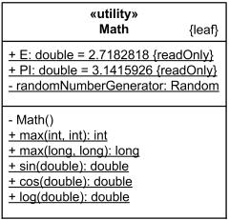

Math is utility class - having static attributes and operations (underlined)

Visibility of attributes and operations

Public (+): member of class is directly accessible to other objects; part of public interface

Private (-) : member is hidden from public use; only accessible to other members within the class

Protected (#): special visibility scope applicable to inheritance only

Relational among classes

A class may be involved in one or more relationships with other classes. A relationship can be one of the following types:

Inheritance (or Generalization):
- Represents an ―is-a‖ relationship.
- An abstract class name is shown in italics.

- SubClass1 and SubClass2 are specializations of SuperClass. Generalization
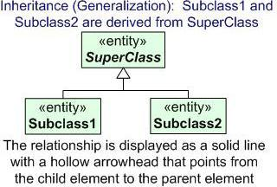

Association

• Simple association:
o A structural link between two peer classes.
o There is an association between Class1 and Class2

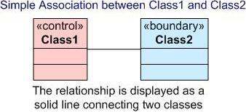

Associations can be one of the following two types or not specified.

Composition:

Represented by an association line with a solid diamond at the tail end. A composition models the notion of one object "owning" another and thus being responsible for the creation and destruction of another object. A special type of aggregation where parts are destroyed when the whole is destroyed.

Objects of Class2 live and die with Class1. Class2 cannot stand by itself.
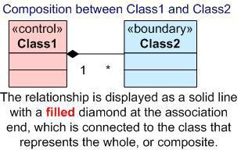

Aggregation:

Represented by an association line with a hollow diamond at the tail end. An aggregation models the notion that one object uses another object without "owning" it and thus is not responsible for its creation or destruction.

It is a special type of association. It represents a “partof” relationship.

Class2 is part of Class1.

Many instances (denoted by the *) of Class2 can be associated with Class1.

Objects of Class1 and Class2 have separate lifetimes.
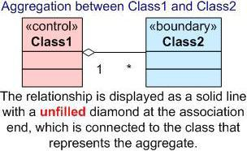

- DEPENDENCY

A dotted line with an open arrowhead that shows one entity depends on the behavior of another entity. Typical usages are to represent that one class instantiates another or that it uses the other as an input parameter.

It exists between two classes if changes to the definition of one may cause changes to

the other (but not the other way around).

Class1 depends on Class 2
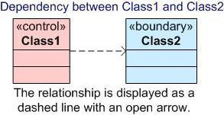

Here is an example of a UML class diagram that holds most of the more common features. The above diagram contains classes, interfaces, inheritance and implementation lines, aggregation lines lines, dependency lines and notes

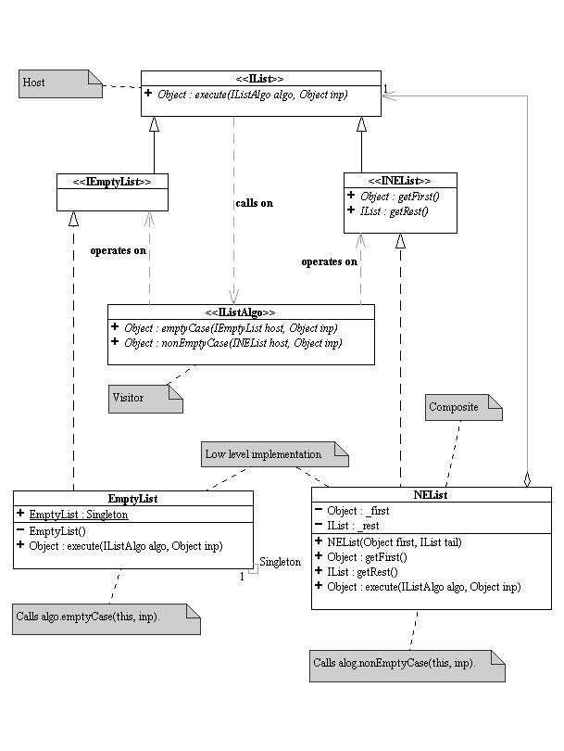

ASSIGNMENT 1

- You have been given the following case study ;
CASE STUDY - LIBRARY (BORROW BOOK) MANAGEMENT SYSTEM
Librarian lends books
Librarian maintains the list of all the members of library
Borrower makes reservation online
Borrower can remove reservation online
Librarian issues books to the borrower
Librarian calculates dues to be paid by the borrower
Borrower issues/returns books
Librarian places order about the requirements to the master librarian
Librarian updates the system
Master librarian maintains librarians
ACTORS
- Librarian
- Borrower
- Catalog
- Master librarian
VERBS
- Borrower
- Logs into the system
- Browses/searches for books
- Makes/removes reservation
- Views results and reports from the library application system
- Librarian

Present the information above in a Class diagram UML diagram.

ASSIGNMENT 2
- Draw a class diagram representing a book defined by the following statement: “A book is composed of a number of parts, which in turn are composed of a number of chapters. Chapters are composed of sections.” Focus only on classes and relationships
- Extend the class diagram in (a) above to include the following attributes:

- a book includes a publisher, publication date, and an ISBN

- a part includes a title and a number

- a chapter includes a title, a number, and an abstract

- a section includes a title and a number

